**DESIGN STORAGE DEVICE**

Examples: google drive, drop box, apple i cloud, Microsoft one drive.

**Step-1**: Define problem Scope and Requirements

Candidate: What are the most important feature?

Interviewer: Upload, download, sync and notification

Candidate: Is this a mobile app, web app or both?

Interviewer: both

Candidate: what are the supported file format?

Interviewer: Any file

Candidate: Do files need to be encrypted?

Interviewer: yes

Candidate: Is there is a file size limit?

Interviewer: Yes, file size should be less than 10GB.

Candidate: How many users the product have.

Interviewer: 50M and 10M DAU(Daily Active User)

System Should have-: Reliability , Fast Sync Speed, Bandwidth usage ,Scalability and High availability

**Step-2** : Determine Capacity estimates

Assume the application has 50M user and 10M DAU

User get 10GB free space

Assume user upload 2 file per day and the average file size is 500KB

1:1 read to write ratio

Total allocated space=50M*10GB=500PetaByte

QPS(Query per second) for upload API=10M*2/24/3600=240

Peak QPS=2*240=480

**Step-3: High Level Design**

1. A server for upload and download files
2. A database to keep track of user details
3. A storage system to store files

**API Design: we required three api**

1. **Upload**
2. **Download**
3. **getVersion**

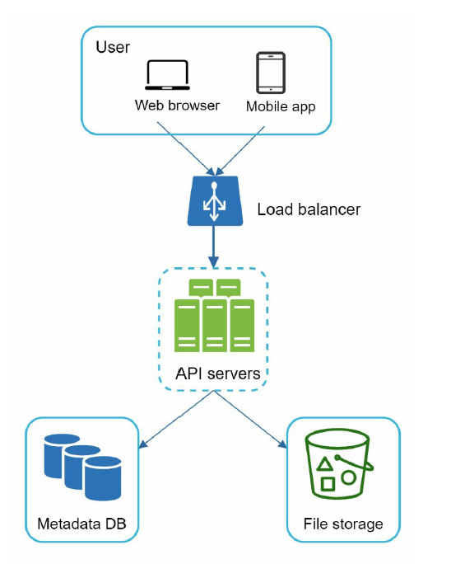

For large storage system like google drive the sync is a major issue. We can handle this by first process based. The user processed first will get the option to update while other can have get a sync conflict and the conflict file will be tracked.

**High level Design:**

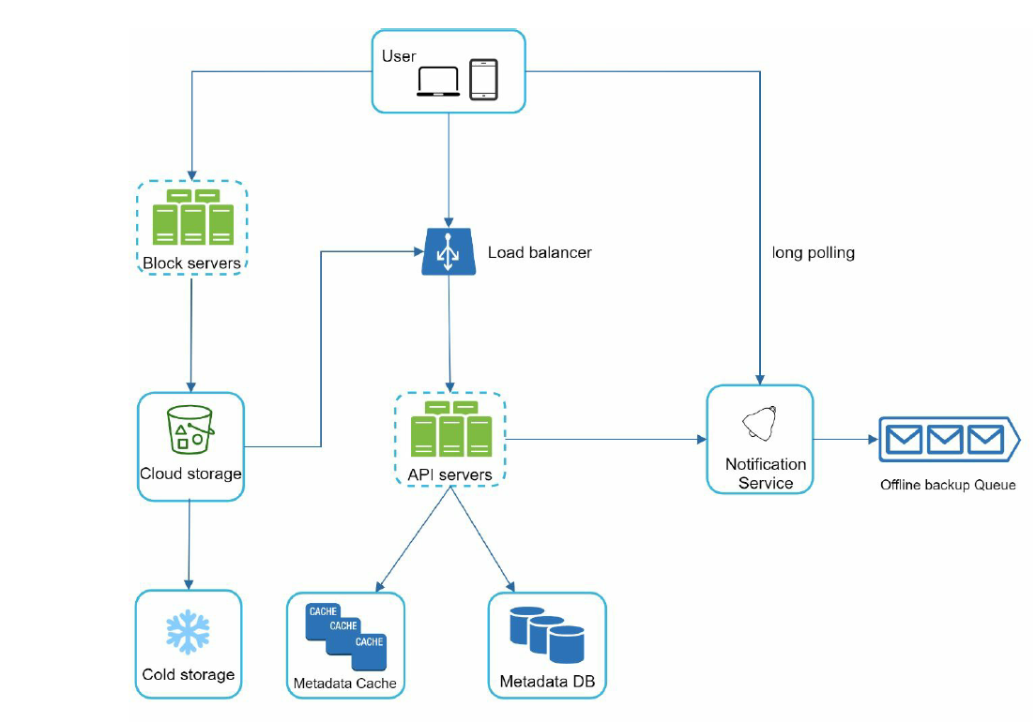

User: User can be a mobile app or a web app.

Block Server: It upload blocks to cloud storage. Block storage referred to as a block level storage – it is a technology to store data files on cloud based environment. A file can be divided into several blocks and each blocks with a unique hash value. Each block treated as independent and stored to s3.

Cloud storage: A file split into a smaller block and stored to the cloud storage.

Cold Storage: Store inactive data.

Metadata DB: Store meta-Data.

Metadata Cache: used for fast retrieval.

Notification service: It is a publisher/subscriber system that allows data to be transferred

from notification service to clients as certain events happen.

Block Server:

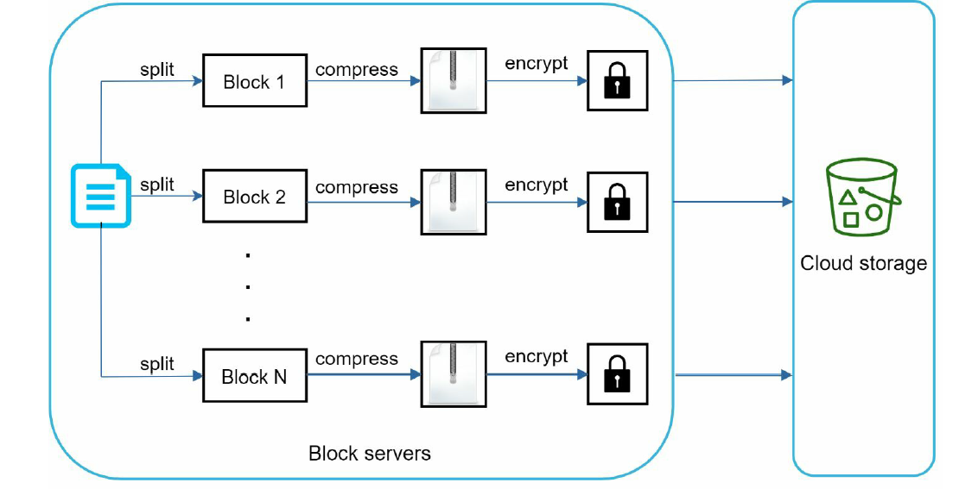

Metadata Database:

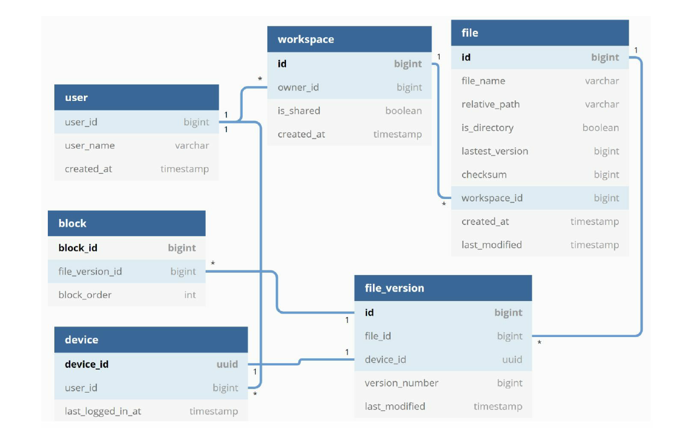

User: Basic user information.

Device: Device table have device info. User can have many devices.

Workspace: It is the root directory.

File : details about the file.